**Common patterns**

**Long diagonals** - correspond to a major repeating theme (chorus, or chorus-like).

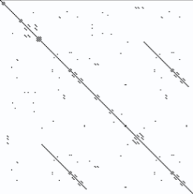

**Striped squares** - consists of a phrase repeatedly chanted, like: *where is my mind, where is my mind, where is my mind OR do re me do re me.* the distance between the stripes increases with the length of the repeated phrase.



**Checkerboards** – like **Striped squares,** where the length of the repeated phrase is two words/notes.



**Filled-in blocks** - another case of **Striped squares**, where what's chanted is just a single word/note.

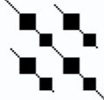

**Verses and bridges** – are typically distinguished by their lack of significant long-range repetition.